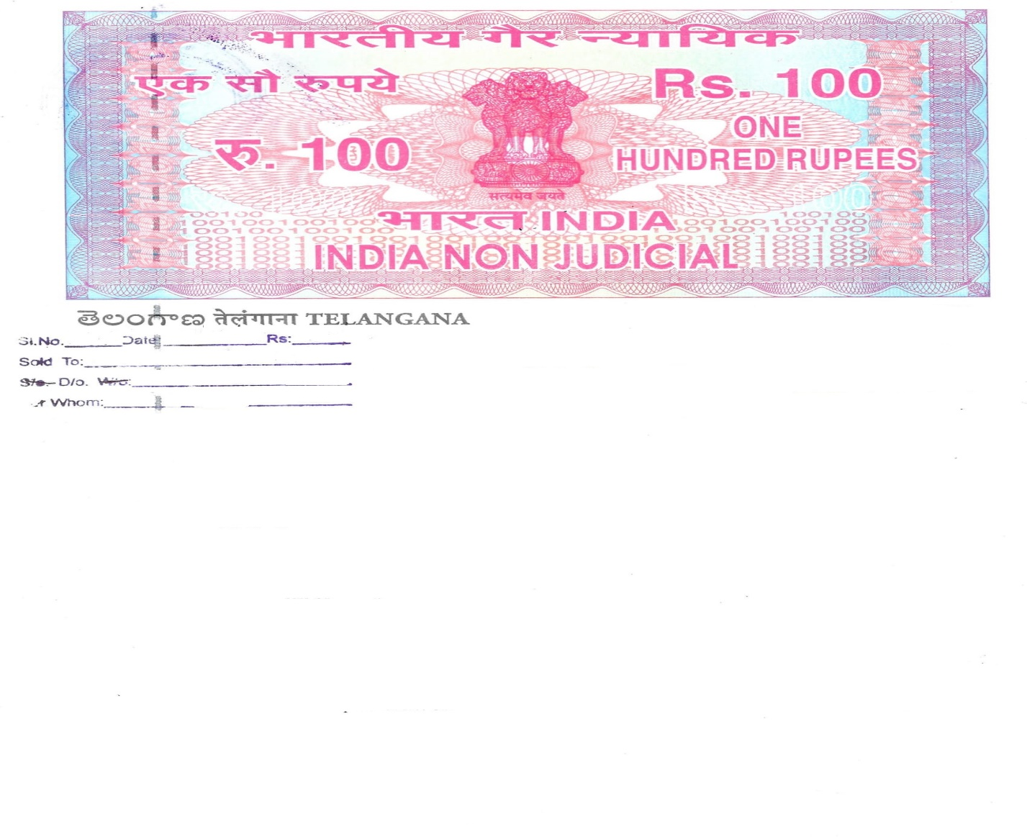

Dummy Stamp

AFFIDAVIT

I, the undersigned, Miss. Shraddha Ambadas Kannor aged 23 years, Indian inhabitant residing Plot No 12, Ravalgaon Colony, Ganesh Nagar, Malegaon Camp, Dist. Nashik do hereby state and declare on solemn affirmation as under: -

I hereby accept the assignment to the post of **Assistant Professor** with order No. Pri/APT/ACD/Cont. Lect./57/2022 dated 03/11/2022 along with all the terms and conditions as laid down in this behalf subjected to rules and regulations.

I am making this affidavit to produce the same before the concerned authorities for the record and to do the needful.

What is stated hereinabove is true and correct to the best of my knowledge and belief.

Deponent

(Shraddha Ambadas Kannor)